**Average velocity of a cart on an inclined plane**

(we measure the time of a cart passing the photogate after accelerating on an inclined plane and verify the result)

Yang Bai 999006125 [bai06125@gtiit.edu.cn](mailto:bai06125@gtiit.edu.cn)

Tianhai Luo 999006513 [luo06513@gtiit.edu.cn](mailto:luo06513@gtiit.edu.cn)

**Abstract**

In this experiment, we want to measure the velocity of a cart after accelerating for some distance on an inclined plane. We release the cart with a picket fence on a slightly inclined plane which is smooth enough so that the friction can be neglected. After accelerating for some distance and reach the photogate, the time of the picket passing through the photogate is recorder, and we can therefore calculate the velocity of the cart. We will accordingly verify the result. The plane is as smooth as possible to reduce the influence of friction so that the verification can be simplified. The length of the distance the cart travels, the length of the picket fence, the angle of the inclined plane are measured for the verification. We came to a concrete understanding of the velocity of the cart, which fits the theoretical result perfectly.

**Theoretical background**

For an object with constant acceleration, after traveling for certain distance, the velocity, the distance it travel, and the acceleration have below relation.

$V_{f}^{2}-V_{i}^{2}=2ax$ ①(eq1)

$V_{f}$ is the final velocity after traveling the distance

$V_{i}$ is the initial velocity before traveling the distance

$a$ is the acceleration

$x$ is the distance the object travels.

The time of an object with **constant** acceleration travellingdistance can be calculated by such equation

T= $\frac{d}{Vavg}$ $Vavg=\frac{Vi+Vf}{2}$ ②(eq2)

T is the time

D is the distance

Vavg is the average velocity

Vi is the initial velocity

Vf is the final velocity

For the acceleration caused by gravity along an inclined plane

$a=g*sin⁡(θ)$ ③(eq3)

$a$ is the acceleration along the plane

$g$ is the gravitational acceleration

$θ$ is the angle between the inclined plane and horizon

**Material and methods**

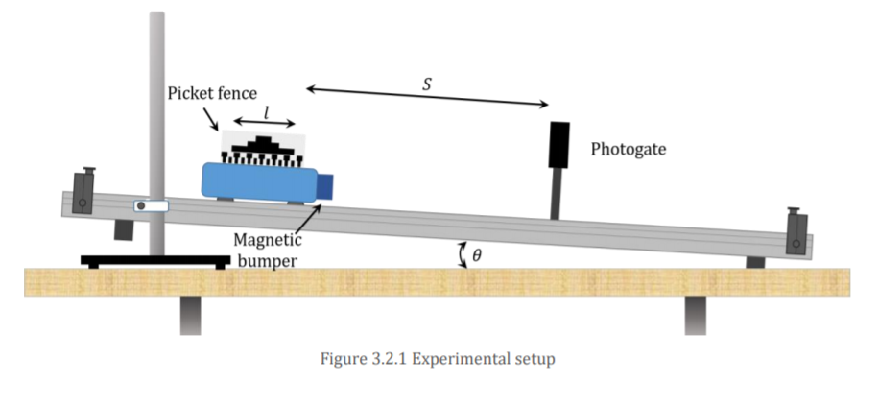

As is shown in the upper graph, the experiment is performed by releasing the cart with a picket. The cart accelerates along the track and reaches the photogate with a certain velocity. The picket fence will then block the photogate during. The photogate will record the time it is blocked. Length of the picket fence is also measured using ruler so that we can calculate the average velocity of the cart when it passes through the gate.

The distance S and picket fence length L are measured by ruler. The angle $θ$ is measured by gradienter. A theoretical average velocity can be calculated accordingly for verification with a given local gravitational acceleration G.

**S=0.18m ± 0.001m**

**L=0.10m ± 0.001m**

**Results and discussion**

We repeated the experiment for 158 times and plot all the data into a list in python (after removing the outliers using Chauvenet 's criterionappendix1.1) to perform the data analysis next.

First, we chose 20/50/150 number of data separately and randomly. We got their average, standard deviation and standard error (Figure1.4), and we draw them as a histogram with a theoretical line of the normal distributionappendix1.2 (Figure1.1 1.2 1.3).

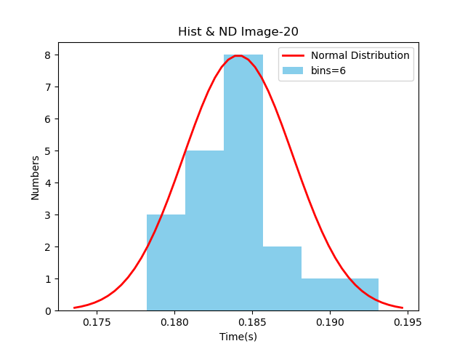

(Figure1.1)

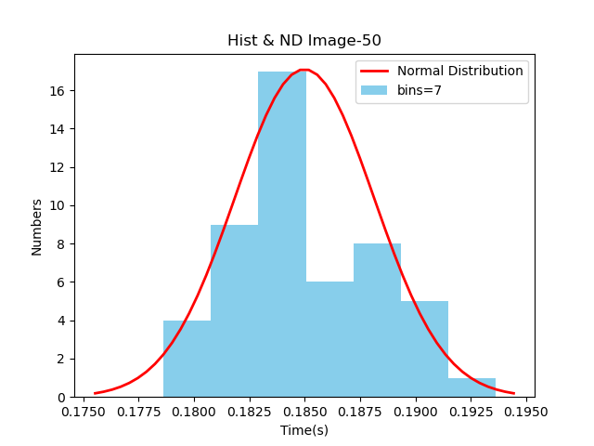

(Figure1.2)

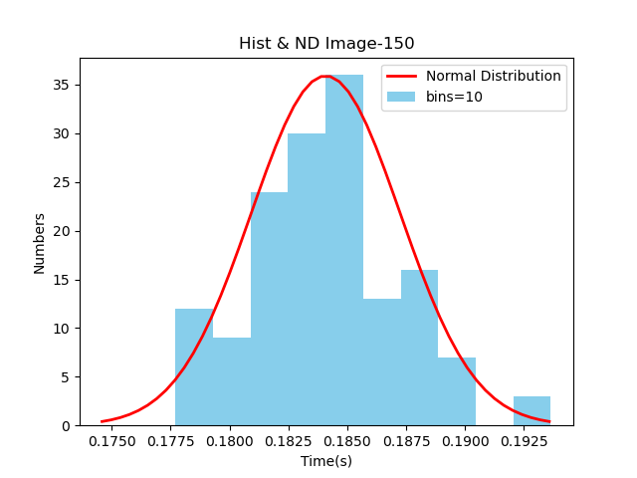

(Figure1.3)

|  |  |  |  |
| --- | --- | --- | --- |
| Data  Nums | 20 | 50 | 150 |
| Average | 0.184758999 | 0.184015580 | 0.184627266 |
| STDEV | 0.003398693 | 0.003100991 | 0.003086027 |
| STDER | 0.0007599709 | 0.0004385463 | 0.0002519730 |

(Figure1.4)appendix1.3

We can conclude that as the number of samples increases, the data are moving closer to the average, and the number of data which are relatively distant from the average becomes less. Graphically, we can come to a preliminary judgment that this data **do have the properties of normal distribution.**

As for verification. We use measured data.(appendix 1.5)The theoretical time is0.180[s], which is smaller than the average time. We believe the deviation is caused by unavoidable friction and the air friction. The plane and the air assert friction which actually slows down the acceleration of the cart, making the theoretical time numerically smaller than the time recorded by the photogate.

**Conclusions**

After calculationsappendix1.4, we can get the error of $∆t$, which is $δt=0.037655252$. The theoretical results agree with the measured result, therefore we can accept the experimental outcome.

**Reference**

**Gtiit moodle website**

**https://moodle.gtiit.edu.cn/moodle/pluginfile.php/36017/mod_resource/content/0/3.2%20Average%20velocity%20lab%20guide.pdf**

citing Local gravitation acceleration of Shantou and Figure3.2.1 Experimental setup

**Appendix**

Appendix1.1: The Chauvenet’s criterion.

(Implemented by code in Python)

1. def RomanTest(_d):
2. _SDE = np.std(_d)
3. _AVE = np.average(_d)
4. n = len(_d)
5. c = 0.9969+0.4040*(math.log(n))
6. X_MAX = _AVE + c*_SDE
7. X_MIN = _AVE - c*_SDE
8. BADDATA = []
9. GOODDATA = []
11. for i in range(n):
12. if X_MIN < _d[i] < X_MAX:
13. GOODDATA.append(_d[i])
14. else:
15. BADDATA.append(_d[i])
17. if len(BADDATA) == 0:
18. return GOODDATA
20. return RomanTest(GOODDATA)

Appendix1.2:

Normal distribution:

$f\left(x\right)=\frac{1}{\sqrt{2π}σ}exp⁡(-\frac{{(x-μ)}^{2}}{{2σ}^{2}}$)

$μ$ = Average of the data

$σ$ = The STDEV of the data

Appendix1.3:

$$Ave=\frac{\sum_{k=0}^{n}{a_{k}}}{n}$$

$$STDEV=\sqrt[2]{\sum_{k=0}^{n}{{(a_{k}-\overline{a})}^{2}}}$$

$$STDER=\frac{STDEV}{n}$$

For every equation, n equals to the number of value in the data

Appendix 1.4:

$$δt=\sqrt{{(\frac{∂t}{∂L}×δL)}^{2}+{(\frac{∂t}{∂g}×δg)}^{2}+{(\frac{∂t}{∂L1}×δL1)}^{2}+{(\frac{∂t}{∂L2}×δL2)}^{2}+{(\frac{∂t}{∂θ}×δθ)}^{2}}$$

$$δL=δL1=δL2=0.001[m]$$

$$δg=0.000005[\frac{m}{s}]$$

$$δθ={0.005}^{o}$$

Appendix 1.5

Our measurement:

Distance between picket and photogate $L_{1}=19[cm]$

Length of the picket fence $L_{2}=10[cm]$

Angle between plane and horizon $θ=4°$

Gravitational acceleration in Shantou

$$g=9.79127\left[m/{s^{2}}\right]$$

The velocity when picket fence reaches photogate

$$v_{1}^{2}-0=2∙gsin(4∘)∙L_{1}$$

The velocity when picket fence leaves photogate

$$v_{2}^{2}-0=2∙gsin(4∘)∙{(L_{1}+L}_{2})$$

Average velocity of picket during the passage of photogate

$$v_{avg}=\frac{v_{1}+v_{2}}{2}$$

Duration time of the picket’s passage

$$t=\frac{L_{2}}{v_{avg}}$$